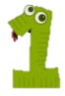

St. John School

Family Math Night

Color a picture when you finish a game or activity. Color 5 or more and get a prize!

St. John School

Family Math Night

Color a picture when you finish a game or activity. Color 5 or more and get a prize!