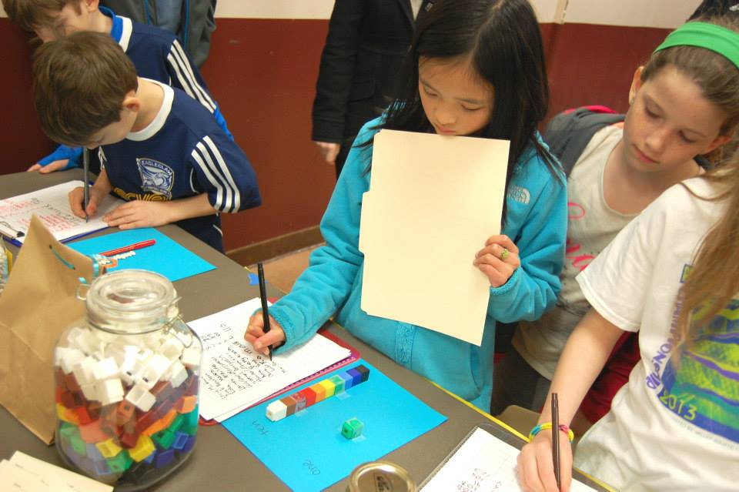

St. John School

Family Math Night

Egan Hall

Tuesday April 28th 6:00pm-8:00pm

## Grades PK – 5

## Come and celebrate Math!