Snap!  Deal all cards. Keep cards face down. Take turns turning over a card and putting it in the middle of the group. When two consecutive cards match, shout, “Snap!” and hit the cards. The fastest person keeps the pile of cards and when one player has all of cards s/he wins! | Read a Book like…  * Fish Eyes: A Book You Can Count On  * The Grouchy Ladybug  * Twenty Big Trucks in the Middle of the Street  * Feast for 10  *Chicka, Chicka 1 2 3  *Out for the Count: A Counting Adventure | Measuring  Find 10 different objects in your home. Sort them into: Things shorter than your hand  Things the same length as your hand  Things longer than your hand |  | Adding Bracelet  Thread 10 beads on a pipe cleaner and to make a bracelet. Can you show ways to make 10 like, 3 and 7 more make 10.
Play a Game like…  Chutes and Ladders  Dominoes  HiHo! Cherry-o!  Uno!  The Ladybug Game  The Sneaky, Snacky Squirrel Game | Memory Match  Get 20 notecards. On ten cards write the numbers 1-10. On the other cards put 1-10 stickers. Now you can play a memory game!  Lay all the cards face down and take turns flipping over 2 cards. If you find a pair keep them! The winner has the most cards when all pairs have been matched. | Sing a Song!  Sing or say some math-themed rhymes.  (you can find some on the back of this sheet!) |  | Simon Says…  Simon says, ‘Jump 3 times’. Simon says ‘touch your toes 7 times’  Simon says, ‘clap 9 times’  Remember if the sentence does not start with ‘Simon Says’ do not do it or you are out!
Measuring  Find 5 different objects in your home. Use a ruler to measure them to the nearest inch. | Estimation  Go to the grocery store. Estimate how much 4 apples will weigh. Use the scales to weigh them. Do you think a bunch of bananas weighs more or less? Weigh it to find out. | Skip-Counting  Practice counting  in ones to 100  in twos to 20  in tens to 100  in fives to 50  and even backwards in ones from 10 or 20! |  | Read a Book like…  *Have you seen my Dragon?  *Max Found Two Sticks  *Ten in the Bed  *The Doorbell Rang  *Inch by Inch  *The Greedy Triangle
Capacity  Find the largest bowl in your kitchen. Estimate how many cups it can hold. Now find out! | Roll and Build  Roll the die. Stack a tower with that number of blocks.  If that is easy then roll two dice, add them and then make a tower.  Now roll the dice and make a second tower. Which is more and less? | Time  Estimate how many times you can do the following things in 1 minute:  hop on one foot  write your name  sing the ABC song  Now find out! | Shape Walk  Go for a walk around your neighborhood. What shapes can you see?
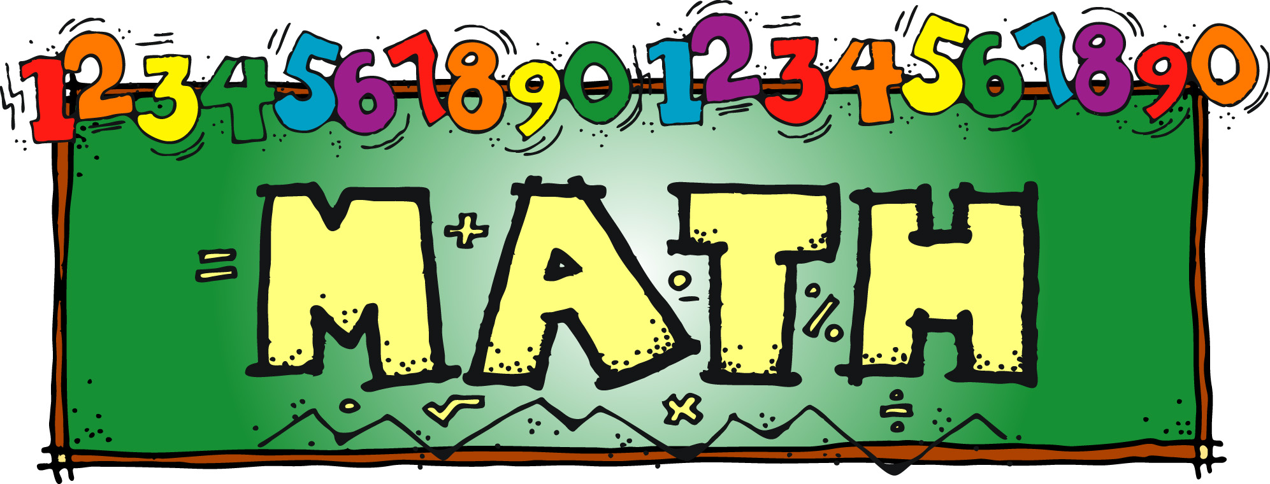
During April
choose 10 or more activities to do below. Color them in when finished.
Return to your teacher on April
30th to be entered to win a prize!

Counting Songs and Rhymes
One, two, three, four, five, once I caught a fish alive.  One, two, three, four, five,  Once I caught a fish alive.  Six, seven, eight, nine, ten.  Then I let him go again.  Why did you let him go?  Because he bit my finger so.  Which finger did he bite?  This little finger on my right. | Five Little Ladybugs  Five little ladybugs climbing up a door,  One flew away and then there were four.  Four little ladybugs sitting in a tree,  One flew away and then there were three.  Three little ladybugs landed on a shoe,  One flew away and then there were two.  Two little ladybugs looking for some fun,  One flew away and then there was one.  One little ladybug sitting in the sun,  She flew away and then there were none. | This old man, he played one  He played knick-knack on my thumb  Knick-knack paddy whack  Give the dog the bone  This old man came rolling home.  This old man, he played two  He played knick-knack on my shoe  Knick-knack paddy whack  Give the dog the bone  This old man came rolling home.  This old man, he played three  He played knick-knack on my knee  Knick-knack paddy whack  Give the dog the bone  This old man came rolling home.  This old man, he played four  He played knick-knack on my door  Knick-knack paddy whack  Give the dog the bone  This old man came rolling home.  This old man, he played five  He played knick-knack on my hive  Knick-knack paddy whack  Give the dog the bone  This old man came rolling home.  This old man, he played six  He played knick-knack with some sticks  Knick-knack paddy whack  Give the dog the bone  This old man came rolling home.  This old man, he played seven  He played knick-knack up in Heaven  Knick-knack paddy whack  Give the dog the bone  This old man came rolling home.  This old man, he played eight  He played knick-knack on my gate  Knick-knack paddy whack  Give the dog the bone  This old man came rolling home.  This old man, he played nine  He played knick-knack on my spine  Knick-knack paddy whack  Give the dog the bone  This old man came rolling home.  This old man, he played ten  He played knick-knack once again  Knick-knack paddy whack  Give the dog the bone  This old man came rolling home.
Skip Counting Song  (to the tune of “Skip to my Lou’)  Skip count, skip count, count by 2’s  Skip count, skip count, count by 2’s  Skip count, skip count, count by 2’s  We can count to 20.  “2, 4, 6, 8, 10, 12,14,16, 18, 20!”  Skip count, skip count, count by 5’s  Skip count, skip count, count by 5’s  Skip count, skip count, count by 5’s  We can count to 50.  “5, 10, 15, 20, 25, 30, 35, 40, 45, 50!”  Skip count, skip count, count by 10’s  Skip count, skip count, count by 10’s  Skip count, skip count, count by 10’s  We can count to 100.  “10, 20, 30, 40, 50, 60, 70, 80, 90, 100!” | One, two, Buckle my Shoe  One, two, buckle my shoe.  Three, four, shut the door.  Five, six, pick up sticks.  Seven, eight, lay them straight.  Nine, ten, a good fat hen.  Eleven, twelve, dig and delve.  Thirteen, fourteen, Maids a-courting.  Fifteen, sixteen, maids in the kitchen.  Seventeen, eighteen, Maids a-waiting.  Nineteen, twenty, My plate’s empty.

